Client
City of Pompano Beach

Scope of Services
SRF Compliance Services
during the Construction
Phase: logging, reviewing,
and evaluating a variety of
information to maintain
CWSRF compliance

Contact
Mr. A. Randolph Brown
Utilities Director
City of Pompano Beach
1205 N.E. 5th Avenue
Pompano Beach, FL 33061
954.545.7043
randolph.brown@copbfl.com

Start Date
05/2023

Completion Date
11/2023 (est.)

Construction Cost
$1,840,250

Key MBC Staff
Frank A. Brinson, P.E.
Andrew Barba, P.E.
Mathew Marsh, P.M.P.
Audra McCafferty, P.E.

Key Features
SRF Compliance Services for Drainage Improvements Project
Construction Phase State Revolving Fund (SRF) Compliance Services for the
N.E. 3rd Street and N.E. 4th Street Drainage
Improvements Project
Pompano Beach, Florida

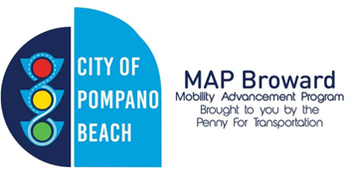
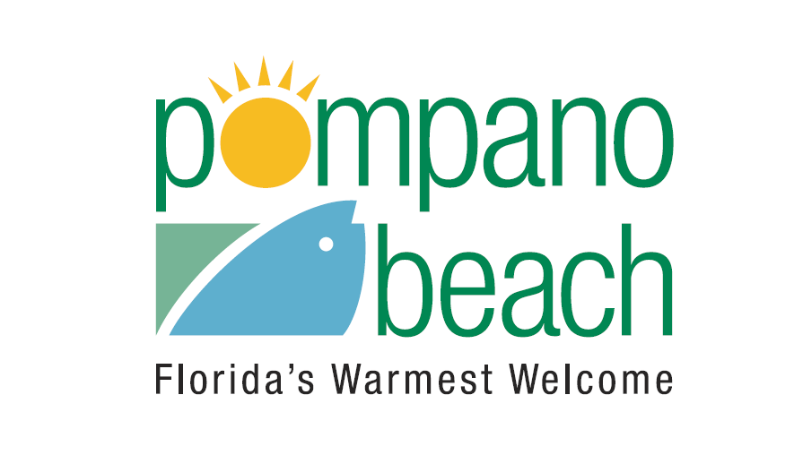

Background
Under a separate Work Authorization, McCafferty Brinson Consulting, LLC, assisted the City of Pompano Beach with procuring a Clean Water Start Revolving Fund (CWSRF) Program loan for the construction of the N.E. 3rd Street and N.E. 4th Street Drainage Improvements Project. This work authorization is for a continuation of State Revolving Fund (SRF) Compliance Services during the Construction Phase of the project.

The Project
The scope of services includes:

- CWSRF Compliance Monitoring
- SRF Bid Document Submittal Checklist
- Project Progress Meetings and Site Visits
- AIS Certification and Submittal Review
- Labor Interviews
- Pay Requests and Certified Payroll
  - The Consultant shall log, review, and evaluate the certified payroll submitted by the Contractor, provided by the Engineer-of-Record, and evaluate compliance with the applicable prevailing wage rates.
- Loan Disbursement Requests
  - As work progresses, the Consultant shall prepare and submit Loan Disbursement Requests on a bi-monthly basis, and one final disbursement request upon Final Completion of the Project.
- SRF Project Closeout
SRF funding was acquired in March 2023. Final Completion is anticipated to occur in November 2023.

