Client
City of Pompano Beach

Scope of Services
Preparation, review, and logging of program compliance documentation

Contact
Ms. Tammy Good
Utilities Treatment Plants
Project Manager
City of Pompano Beach
1205 N.E. 5th Avenue
Pompano Beach, FL 33061
954.786.5512
Tammy.Good@copbfl.com

Start Date
04/2023

Completion Date
Ongoing

Engineering Fee
$100,000

Surtax Grant Amount
$4.4 million

Key MBC Staff
Audra McCafferty, PE
Andrew H. Barba, PE

Key Features
Project included certified payrolls, time records, invoices, financial reports, monthly schedule reports, monthly material changes, annual performance metrics, monthly utilization reports, escalation costs request, and grant fund advance requests.
Surtax Program Compliance Assistance
Pompano Beach, Florida
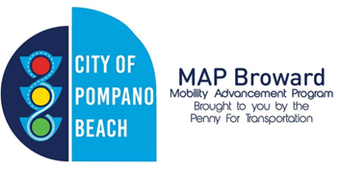
Background
Broward County voters approved a 30-year, one percent sales surtax for transportation in November 2018. Surtax revenues were received by Broward County in 2019. The City of Pompano Beach has been approved for Surtax funding for several projects during Cycle 1 of the program. The City has entered an Interlocal Agreement (ILA) with the County for each approved project. The surtax program ILAs between the County and grant recipients require that recipients perform certain administrative and documentation activities to receive grant funds and remain in compliance with the program.
The Project
Under this work authorization MBC will provide assistance with compliance-related Post-Award Activities on an as-needed, as requested basis from the City. MBC’s services under this work authorization may include, but may not be limited to, the following: preparation, review, and/or logging and collation of the following program, compliance documentation (as identified in the ILA between Broward County and the City), certified payroll, time records, invoices, quarterly and monthly financial reports, monthly schedule reports, monthly material changes, annual performance Metrics, monthly MPO Program Management Office forms, Monthly Utilization Reports (MUR), escalation costs request, and grant fund advance requests.

